Nepal College of Information Technology
Unit Test
Fall 2012
Program : BE CE Time : 2 hrs
Semester : (III) FM : 70
Subject : Network Theory PM : 35

- Candidates are requested to give their answer as far as practicable in their own words.
- The figure in the margin indicates the full marks
- Attempt ALL question

1. a) A DC voltage of 100v is applied to a coil having R=10Ω, L=10H. What is the value of current 0.1sec later the switching on. 7

b) In the given circuit switches k is changed from position 1 to 2 at t=0. Steady state condition having reached before switching find
i, 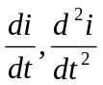 at t=0⁺ 8

2. a) Find 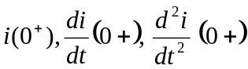 for the given circuit. Assume no initial energy is stored and switch is closed at t=0 sec. 7

b) In the given RLC parallel circuit determine 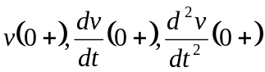 8

3. a) In the given circuit switch k is closed at t=0. Find the values of i(0+), i6_{Ω}(0+) i3_{Ω} (0+), i_{L} (0+), i_{e} (0+), V_{L} (0+), V_{6Ω} (0+), V_{8Ω} (0+) and V_{3Ω}. (0+) 7

b) In the given circuit C₁ is charged to 100v in the polarity as shown. Switch k is closed at time t=0. Find the values i₁ , i₂, 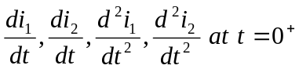 8

4. a) A step De voltage of 20v is applied to a series R-L-C circuit consisting of R=9Ω, inductor l=1H, and capacitance c=0.05μF. Obtain the general solution for i(t) through this circuit if the capacitor c is initially uncharged. Obtain particular solution for the current i(t) 8

b) Show that i(t)=k,e^{-3t} +k₂ e^{-t} is the solution of the differential equation 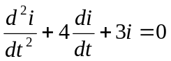 7
5. Write short notes (any two) 5*2=10

a) Steady stake and transient current on RL circuit.
b) Time constant on RC series circuit.
c) Time constant on RL series circuit.

